Create your own Pocket Guide with health terms!
This is a template and you are asked to fill in relevant health terms used in your mother tongue, the language of your country, in English and/or French.
You may use terms of physical and mental health and any other terms you regard as important for your health (terms, issues and symptoms). For inspiration, some words are already provided. Please use a digital device (apps or by browsing a computer).
Take 30 minutes to do this - good success!
Term in your mother tongue | Term in your host country | Term in English | Term in French
 |  | hospital | hôpital
 |  | dentist | dentiste
 |  | headache | mal de tête
 |  | optician | opticien
 |  | disease | maladie

Declaration on Copyright:
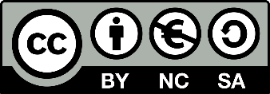
This work is licensed under a Creative Commons Attribution-NonCommercial-ShareAlike 4.0 International License. You are free to:
- share — copy and redistribute the material in any medium or format
- adapt — remix, transform, and build upon the material
under the following terms:
- Attribution — You must give appropriate credit, provide a link to the license, and indicate if changes were made. You may do so in any reasonable manner, but not in any way that suggests the licensor endorses you or your use.
- NonCommercial — You may not use the material for commercial purposes.
- ShareAlike — If you remix, transform, or build upon the material, you must distribute your contributions under the same license as the original.

