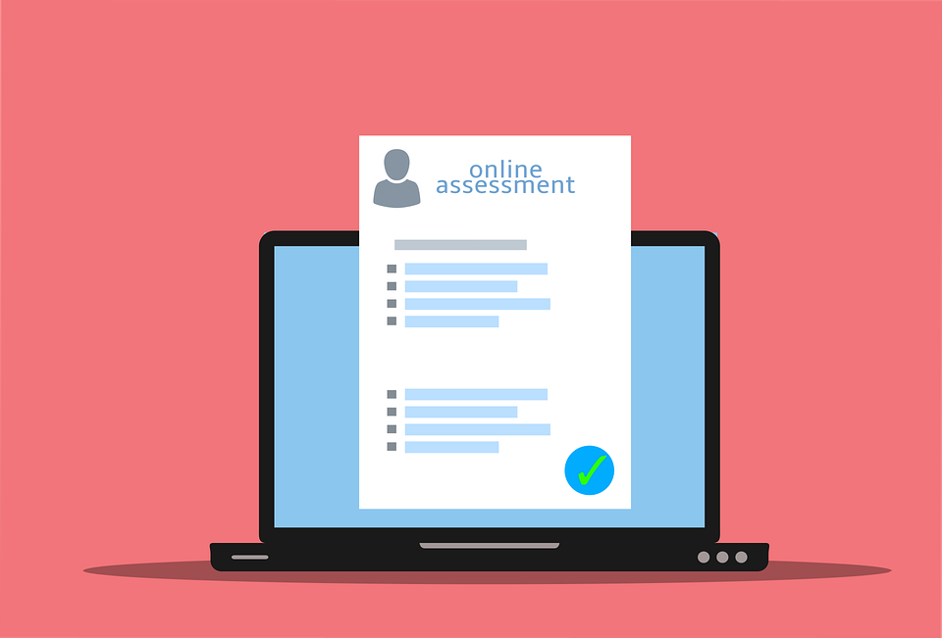
Questionnaire on your criteria for searching the internet for health information
Please answer the following questions

What was the first step in searching online information on health information?
O by a search machine (e.g. Google, Bing, Startpage, Yahoo)
O by entering a specific disease
O by asking another learner what to do
O other

How many steps did it take until you found the expected information?
O 1 step
O 2-5 steps
O more than 5 steps

Was it easy to find the online information?
O Yes
O No

Was it easy to understand the content of the information?
O Yes
O No

Why did you decide to dive deeper into one website than other?
O The text was easy to understand.
O The layout was clear.
O I quickly found what I was looking for.
O I trusted the content because it was provided by a medical expert (e.g. doctor, hospital).
O Other

Did the source offer several healing methods?
O Yes
O No

Did you make an assessment of the source you found online?
O Yes
O No

What was the most difficult issue in finding information? Please describe:
Declaration on Copyright:
This work is licensed under a Creative Commons Attribution-NonCommercial-ShareAlike 4.0 International License. You are free to:
- share — copy and redistribute the material in any medium or format
- adapt — remix, transform, and build upon the material
under the following terms:
- Attribution — You must give appropriate credit, provide a link to the license, and indicate if changes were made. You may do so in any reasonable manner, but not in any way that suggests the licensor endorses you or your use.
- NonCommercial — You may not use the material for commercial purposes.
- ShareAlike — If you remix, transform, or build upon the material, you must distribute your contributions under the same license as the original.

