MIG-DHL- Migrants Digital Health Literacy
DEVELOPMENT OF A TRAINING PROGRAM FOR IMPROVING DIGITAL HEALTH LITERACY OF MIGRANT

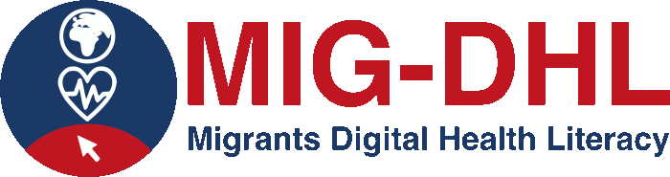

Identification of benefits and challenges of Digital Health online tools

BENEFITS | CHALLENGES

Declaration on Copyright:
This work is licensed under a Creative Commons Attribution-NonCommercial-ShareAlike 4.0 International License. You are free to:
- share — copy and redistribute the material in any medium or format
- adapt — remix, transform, and build upon the material
under the following terms:
- Attribution — You must give appropriate credit, provide a link to the license, and indicate if changes were made. You may do so in any reasonable manner, but not in any way that suggests the licensor endorses you or your use.
- NonCommercial — You may not use the material for commercial purposes.
- ShareAlike — If you remix, transform, or build upon the material, you must distribute your contributions under the same license as the original.

