MIG-DHL- Migrants Digital Health Literacy
DEVELOPMENT OF A TRAINING PROGRAM FOR IMPROVING DIGITAL HEALTH LITERACY OF MIGRANT

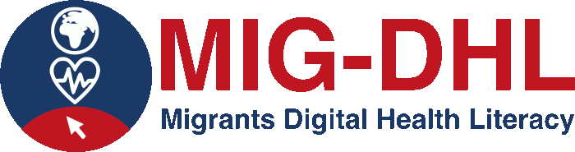

Identification of benefits and challenges of Digital Health online tools

BENEFITS | CHALLENGES

