MIG-DHL- Migrants Digital Health Literacy
DEVELOPMENT OF A TRAINING PROGRAM FOR IMPROVING DIGITAL HEALTH LITERACY OF MIGRANT

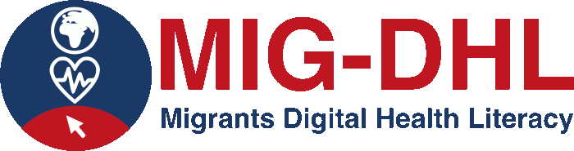

5.4 Assignment in online platform
Seek information in relation to COVID. Please answer to the following questions:
- what is the current situation?
- what are the main health safety measures adopted in the country you live?
- how should you act today if you have symptoms?

