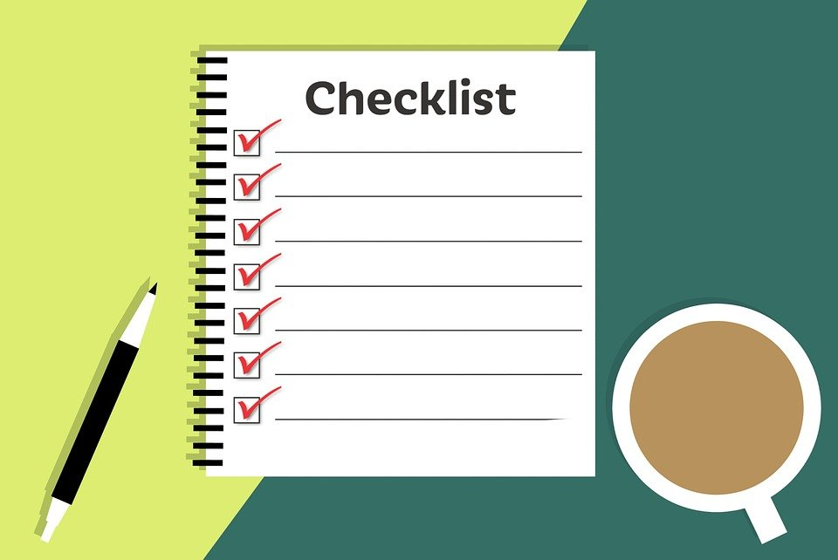

Checklist for a quality assessment of digital health tools

Please check 2 more digital tools (websites, apps, etc) and answer the following questions in the digital questionnaire. Prepare the questionnaire for each tool:
Who is the provider of the tool?
O a hospital
O a doctor
O a health organisation
O a special interest group
O a company
O other

Is the background expertise of the author clearly described?
O Yes
O No

Does the tool provide objective information?
O Yes, the information is provided in a clear and factual language
O No, the information provided is not objective, biased, and formulate assumptions

Is there an imprint?
O yes, an imprint is provided and it is complete including data protection information
O no, the imprint is missing or information is not complete

Is the website up to date?
O Yes, there is a date provided for the last update of the pages
O No, the tool seems outdated

Are there contact details?
O Yes
O Are they easy to find?
O Is a telephone number provided?
O Is a mail contact address provided?
O Does the postal address exist?
O No

Are the sources of content identified and access provided?
O Yes
O by links
O by contacts
O by an address
O No

Is the text reproduced without errors?
O Yes
O No
O The text includes many spelling mistakes.
O The text includes many expressions that I do not know.
O The text is difficult to understand.

Are there advertisements on the pages?
O Yes
O The advertisements are linked to the content of the page.
O The advertisement are random and not linked to the content of the page
O There are hidden advertisements in the text.
O No

Are the layout and user guidance easy to follow?
O Yes
O No

Does the website address have a Hypertext Transfer Protocol (http)
O Yes
O No

Is the domain under which the page can be accessed traceable?
O Yes
O No
O The domain has many hyphens included.
O The domain sounds well-known but the content is not linked to the name.

Would you trust this digital health tool? Please summarize your assessment here:

Declaration on Copyright:
This work is licensed under a Creative Commons Attribution-NonCommercial-ShareAlike 4.0 International License. You are free to:
- share — copy and redistribute the material in any medium or format
- adapt — remix, transform, and build upon the material
under the following terms:
- Attribution — You must give appropriate credit, provide a link to the license, and indicate if changes were made. You may do so in any reasonable manner, but not in any way that suggests the licensor endorses you or your use.
- NonCommercial — You may not use the material for commercial purposes.
- ShareAlike — If you remix, transform, or build upon the material, you must distribute your contributions under the same license as the original.

