MIG-DHL- Migrants Digital Health Literacy
DEVELOPMENT OF A TRAINING PROGRAM FOR IMPROVING DIGITAL HEALTH LITERACY OF MIGRANT

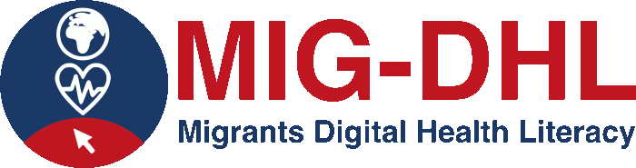
Declaration on Copyright:
This work is licensed under a Creative Commons Attribution-NonCommercial-ShareAlike 4.0 International License. You are free to:
- share — copy and redistribute the material in any medium or format
- adapt — remix, transform, and build upon the material
under the following terms:
- Attribution — You must give appropriate credit, provide a link to the license, and indicate if changes were made. You may do so in any reasonable manner, but not in any way that suggests the licensor endorses you or your use.
- NonCommercial — You may not use the material for commercial purposes.
- ShareAlike — If you remix, transform, or build upon the material, you must distribute your contributions under the same license as the original.

5.1 Assignment in online platform
Conduct the following activities using the proposed digital health tools:
5.1.1) Access the website of the national health system and carry out the following activities:
- Is there any information on vaccinations? Download the lifelong vaccination schedule.
- Find information on the Tetanus vaccine. When you get to the information, take a screenshot.
- What does the national health system say about Preventing alcohol consumption in pregnancy? Point out your answer in the box below:
- What is diabetes and how can it be treated according to the national health system? Please indicate your answer in the box below:
- Find the list of diseases that have national associations formed by the people who suffer from them and, in some of them, also by their family members. When you get to the information, take a screenshot.
5.1.2) Access the patient portal of the Valencian regional health system and carry out the following activities:
- Consult your assigned primary care and specialised care health centres. When you get to the information, take a screenshot.
- Can you request an appointment online if you have symptoms of COVID-19?
5.1.3) Access the APP: GVA+Salut and carry out the following activities:
- Check which hospital you have been assigned to. When you find the information, take a screenshot.
- Make an appointment with your family doctor. Once you have generated it, take a screenshot. In case you do not need to keep the appointment, cancel it.
5.1.4) Visit World Health Organisation Website and carry out the following activity:
- What are the vaccines against COVID that according to WHO meet the necessary criteria for safety and efficacy?
5.1.5) Visit GUIASALUD.ES and carry out the following activities:
- Seek recommendations to improve your quality of life if you have chronic migraine. When you get to the information, take a screenshot.
- Find recommendations for preventing and/or managing sleep disorders in childhood and adolescence. When you get to the information, take a screenshot.

5.1.6) Visit webconsultas and carry out the following activities:
- Find out which foods are forbidden for dogs. When you find the information, take a screenshot.
- Find out which foods to eat with braces and which ones to avoid. When you find the information, take a screenshot.

5.1.7) Visit EFESALUD Spain and carry out the following activity:
- Check out the latest news on Coronavirus.
5.1.8) Visit MUJERYSALUD and carry out the following activity:
- Find out how to prevent dental diseases and point out your answer in the following box:
- What are the first symptoms of pregnancy? Point out your answer in the following box:
5.1.9) Visit PSICOLOGIAYMENTE and carry out the following activity:
- Find information related to the psychology of children's education. When you reach the information, take a screenshot.

